**ASME – journal of computing and information science in engineering**

**Novel Method of Damage Detection of Quasi-Cylindrical Features Based on Point Cloud Profiling (using Rotational and Cartesian profiling)**

E. Ezi, W. Pan, A. P. Longstaff, S. Fletcher

*Centre for Precision Technologies, University of Huddersfield,*

*Queensgate, Huddersfield, United Kingdom*

**ABSTRACT**

Damage detection based on scanned point cloud data is an effective application for reconstructing damaged surfaces and very useful for the reverse engineering applications. Dense 3D point data can be captured across a range of surface types to give measurement information, create geometric samples and perform inspection of the remanufactured object.

In this paper, a novel damage detection method has been developed targeted at quasi-cylindrical features. Scanning was performed using an AACMM to obtain point cloud data of a damaged object. During preprocessing, downsampling of the scanned data was conducted to reduce the number of sampled points by eliminating outliers and noise in the scan, thereby creating a decimated point cloud still having the required features and reducing the time required to perform the process. Profiling of the part was established by creating a rotational sweep over the model to show its boundary spline. The profile of the damaged part was compared to that of the good part as an inspection process in identifying possible damage or distortion in the profile of the part. The method has been successfully applied to real processed data to demonstrate its effectiveness leading to automatic damage detection and can be applied to other primitives.

**KEYWORDS**

*Damage detection, profiling, point cloud*

1. **INTRODUCTION**

Over the last decade, there has been a technological shift in surface metrology resulting in advanced manufacturing, e.g. micro manufacturing and nanotechnology and also, improved surface quality. This technological shift was made eminent by the need to make manufacturing more efficient, economic, less sensitive to the environmental effect on production and also optimising performance. As part of the manufacturing process, point cloud data of a part is developed and for reverse engineering applications, sampled point cloud data are obtained using data acquisition techniques. These techniques could be tactile or optical. Often times, these data acquisition techniques generate huge amount of data which sometimes contains noise and outliers, and one major challenge in the manufacturing process is dealing with this huge amount of data. According to Jiang and Whitehouse [1], size is a big part with respect to function but this positions are changing with increased planar technology and miniaturisation. This means that decimated data can be used for the same application as a dense data set but care must be taken to retain the main features of the object.

As part of the surface analysis of an object, it is very important to develop a digital representation of the part to obtain its dimensional properties and 3D model. Statistical Process Control (SPC) techniques based Profile monitoring are applied to these models which produces a well-established and understood boundary contours of the part. Although its limitation is ambiguity as compared to Aerial analysis of a surface, this approach is quick and simple. This process has to do with the relationship between a response variable measured along with the corresponding values of one or more explanatory variables of a system, to present an interpretation of the systems characteristics [2].

The proposed methodology of the research is shown in Figure 1. Point cloud data acquisition of the part was captured with an AACMM using a suitable scanning strategy. Preprocessing of the data is necessary mostly when a dense data set is obtained from the scan. This is always the case with Articulate Arm where thousands of points are generated per second. Preprocessing helps in reducing point set of the scan and removal of noise and redundant points. This process produces a set of data which might still be very dense containing redundant points. To achieve system efficiency, the dense data is further reduced using sampling modules in removing redundant points to obtain an improved set of data. To achieve this, a downsampling algorithm was applied to reduce the points but keeping a considerable good amount of points to represent the part.

The next stage is the profiling of the scan by centralisation with respect to the X and Y axis. This changes the direction of view of the scan and the profile of the part is projected from the centre point. In rotational matrix, two conventions can be achieved, one is the rotation of axes and the other is part rotation relative to fixed axes, but for this project the axes are rotated relative to the part.

1. EXISTING WORK
   1. POINT CLOUD DATA

The concept of data acquisition is very important in detecting damaged surfaces because this will determine the techniques and methods of detection suitable for the acquired data, as well as the algorithm to produce the desired result and its representation [3]. This process is concerned with the pre-processing of digitized points, curve net construction, surface fitting, as well as post-blending and trimming [4]. The input data for the damage detection process is a large set of points lying on the object surface (or point cloud in x, y and z coordinates) which represents the location of the points in three dimensional (3D) space [3]. Point cloud are mostly produced by laser scanners which are sometimes accompanied by noise and outliers, therefore the need for filtering of the point cloud is eminent. Existing methods for point cloud filtering are categorised into seven (7) classes [5]. Certain factors contribute to the noise contamination of the point cloud data; this includes limitation of the sensors such as Kinect and time of flight cameras, LMS-200 sick lasermounted on a sweeping unit [6], built-in noise of the scanning device, surface topology of the object and external lighting [5].

The process of recovering a digital representation of an object is quite crucial because several factors can affect the integrity of the data, these include measurement errors, missing data and a fault with the scanning device for soft computing. An algorithm was developed for pre-processing/filtering of the point cloud data used for this project. The scan was performed using a handheld scanner and the object was placed on a flat surface. The area between the base of the scanned object and the table was missing some data which was reconstructed.

Data properties, together with the characteristics of the scanned shape, essentially distinguishes the distinct levels of detection methods used in present times. This distinct set of techniques comprises: (1) methods that assume a well-sampled point cloud which is generalized to arbitrary shapes and produce a watertight surface mesh, (2) methods that make very loose assumptions on the quality of the point cloud, (3) methods that operate on specific classes of freeform shapes, and (4) methods that output a non-mesh based shape representation [7].

* 1. DOWNSAMPLING METHOD

Dense 3D models built from scanning processes often contains of noisy data and outliers that makes feature extraction and detection techniques very difficult. Most scanning devices generates thousands of points per seconds and the scanning device used for this project generates 750,000 points per seconds with an ultra-wide laser stripe of up to 150mm. To extract meaningful information from such 3D models, 3D Filtering and Downsampling has become an essential step in preprocessing 3D data. This is the reduction in spatial resolution of the scanned points [8]. Traditional Filtering techniques such as the median and mean filtering has been mostly used in Filtering and Downsampling noisy point clouds [6]. Another technique frequently used is the Voxel Grid. This technique is based on the input space sampling using a grid of 3D voxels to reduce the number of points. And this technique is most applicable in computer graphics to subdivide the input space and reduce the number of sampled points [6], but its major setback is its sensitivity to noisy input spaces (as most points will be approximated with their centroid, it does not represent the underlying surface accurately). The median filtering method is the simplest and most widely used technique. This is because of its simplicity of application and can remove noise based on one condition: if the noisy pixel occupy less than one half of the neighbourhood area. Another noise removal technique is a nonlinear filter called the Bilateral filtering technique. This method removes noise while putting into consideration the corners and edges using Gaussian functions thereby preserving edges but falls short with outliers in the input point cloud [9]. A downsampling technique based on Growing Neural Gas (GNG) network was proposed by [6] which preserves the topology of the 3D model and at the same time calculates the GNG network over the raw point cloud, and is able to deal with outlier of an input space.

In this project, thousands of point were captured to represent 3D information of the object and these points contains noise. As part of the preprocessing of the scanned data, (what type of downsampling) downsampling was applied to the system to reduce the number of sampled points, thereby eliminating certain irregularities and noise in the scan.

The different approaches to the interpolation of scattered data can be classified into global methods, in which each interpolated value is influenced by all of the data, and local methods, in which the interpolated value is only influenced by the values at ‘‘nearby’’ points from the scattered point set. Global methods are practically limited to small data sets due to the computational efforts they require; moreover, an addition or deletion of a data point, or a correction in any of the coordinates of a data point, will modify the interpolated values throughout the entire domain of definition. Local methods, on the other hand, are capable of treating much larger data sets, and they are less sensitive to data modifications, but they may become quite complex, too, if a smooth result is required.

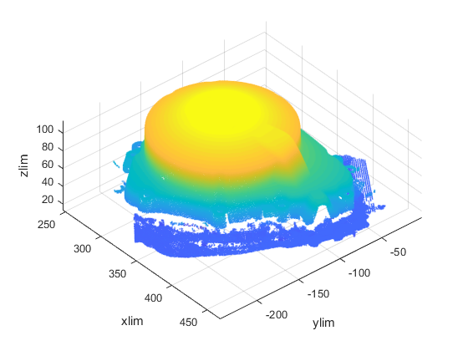 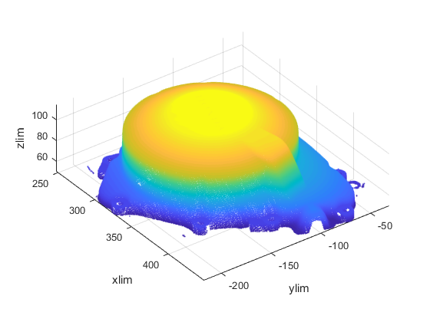

* 1. SURFACE IMPERFECTION CLASSIFICATION

Standard operations in material processing involves several milling operations (end milling, face milling, chamfer milling etc.), drilling, boring, grinding and polishing. These operations produces surfaces of different surface textures and it is necessary to inspect and classify defects on final products occurring as a result of the cutting parameters used, tool misalignment (centreline and angular misalignment), clamping error, machine tool chatter, machine tool offset, wrong program and poor surface finishing etc. Some imperfections results from localised damage experienced during or after manufacturing. For the optical industry, identification of surface imperfections are performed by visual inspection aided by the scattering of light radiating from the surface and this gives a misjudgement of the surface quality[10]. Sometimes, the scattered lights can be seen as undesired veiling glare also known as stray radiation projected on an image plane and they can lead to wrong signal quality at an image sensor. Surface imperfections in very few cases have little or no impact on the performance of the component but can greatly affect its functionality with respect to dimensions and high tolerance factor in precision engineering application. Dimensions may go below or above tolerance limits defeating the application of the part with inference to design intent. For visual inspection, both manufacturer and user have to agree on brightness comparison standard and tolerance level acceptable by both parties. Although this method is subjective, it lacks precision application in terms of dimensional assessment [11]. Two visual inspection methods were described in ISO 14997:2017 [10] as visual inspection without any comparison standard and visual inspection of a surface imperfection when compared to a known artefact. For dimensional assessment of surface imperfection, three methods were described. Firstly is visual inspection of a surface without any comparison standard, secondly is dimensional assessment when compared to a known artefact with specified dimensions and thirdly is dimensional assessment using magnification as well as comparison of known artefact with known size or reticle. An objective method for surface imperfection classification is using computer vision application applications like support vector machine (SVM), extreme learning machine (ELM), genetic algorithm (GA) and semantic segmentation etc. A combination of scale-invariant feature transform (SIFT) and SVM was used by [12] in developing a defect detection algorithm for production line. Firstly, feature detection and extraction was done using SIFT and four SVMs was used for detecting surface imperfections. For this paper, a new classification algorithm known as Deep Convolution Neural Network (DCNN) was used were 80% of the data was used as training data at a learn rate of 0.001 and the remaining 20% as test data. The figure below



Use nurudeen’s algorithm to test the NEU database and use the result here

* 1. PROFILE MONITORING

Profile monitoring is the description of machined profile by identifying parametric models [13]. The machined profile can be represented by the parametric models as distinguished by behaviours that are predictable and has a natural variability. This predictable behaviour can be referred to as manufacturing signature, giving a profile view of the machined part. Manufacturing signature is the standard pattern that distinguishes all the features machined with a process. They are used in designing necessary procedures for profile monitoring. In the work by Gardner et al. [14] and William et al. [15], they both used parametric model known as the smoothing spline for profile monitoring. William et al. [15] also considered nonparametric forms for estimating profiles. According to Chicken [16], the use of spline belongs to a large class for nonparametric estimators that have fewer restrictions than parametric methods portrays undesirable properties but they can be a feasible alternative to parametric models. For a profile with explicitly unsmooth features such as jumps or points of non-differentiability, spline smoothing estimators will not produce a good model of the profile [16]. There are several techniques for achieving optical 3D profile measurement, these include Stereo vision, Fringe Projection Profilometry (FPP), holography etc.[17]. Among these techniques, the FPP is mostly used because of its accuracy and ease of implementation. It consists of two approaches for dynamic profile measurement, first is the reconstruction of dynamic profile from a single fringe pattern and the second approach is the use of high speed phase shifting techniques [17]. With the information obtained from profiling point cloud data, certain applications such as inspection of machined parts to 3D reconstruction and extraction of contour lines of an image becomes achievable.

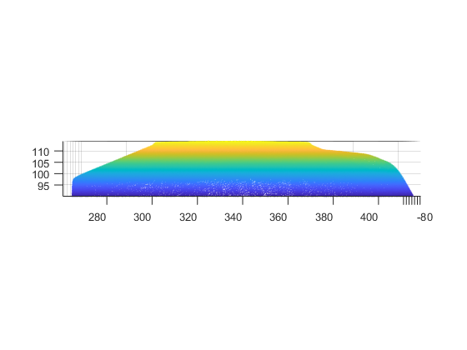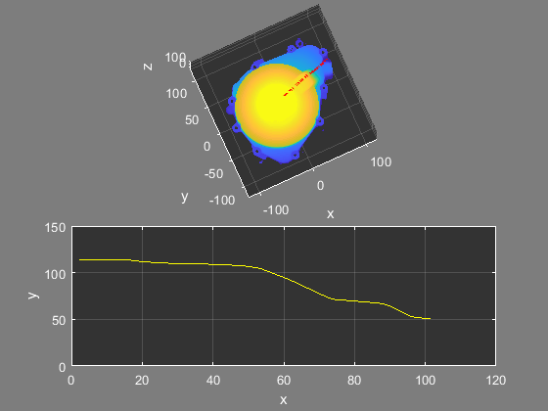

To test the effectiveness of the process, both simulation and experimentation results were presented. An initial profile of the part was created without damage.





Given a vector of position $x_{o},y_{o}$ at an angle $θ$ and radius r, using Pythagoras theorem,

$\cos{θ= \frac{x_{o}}{r}}$, $sinθ= \frac{y_{o}}{r}$

$x_{o}=rcosθ$, $y_{o}=rsinθ$ (1)

If the vector is rotated counter clockwise ($θ$ is positive) at an angle $θ^{'}$ to give a new position of $x_{1},y_{1}$, the angle of the vector at this position is $(θ+ θ^{'})$

$x_{1}=rcos\left(θ+ θ^{'}\right) ,$ $y_{1}=rsin(θ+ θ^{'})$ (2)

Using trigonometric identities

$x_{1}= rcos(θ+ θ^{'})$ (3)

$$= r(cosθcosθ^{'}- sinθsinθ^{'})$$

$$=rcosθcosθ^{'}- rsinθsinθ^{'}$$

$x_{1}= x_{o}cosθ^{'}- y_{o}sinθ^{'}$, $y_{1}= rsin(θ+ θ^{'})$ (4)

$$= r(sinθcosθ^{'}+ cosθsinθ^{'})$$

$$=rsinθcosθ^{'}+ rcosθsinθ^{'})$$

$y_{1}= y_{o}cosθ^{'}- x_{o}sinθ^{'}$ (5)

$$x_{1}= x_{o}cosθ^{'}- y_{o}sinθ^{'}$$

$$y_{1}= y_{o}cosθ^{'}- x_{o}sinθ^{'}$$

$\left[\begin{matrix}x_{1} \\ y_{1}\end{matrix}\right]= \left[\begin{matrix}cosθ^{'} & -sinθ^{'} \\ sinθ^{'} & cosθ^{'}\end{matrix}\right]\left[\begin{matrix}x_{o} \\ y_{o}\end{matrix}\right]$ (6)

A three-dimensional rotational matrix is a representation of a counter clockwise rotation by an angle θ with respect to a fixed axis along the unit vector ń. The functionality of the rotational matrix is on vectors resulting in more rotated vectors while coordinate axes are fixed. This is referred to as active transformation. The real 2x2 special orthogonal matrix is the representation of how the x-y plane rotates by an angle θ measured counter clockwise from the + x-axis.

$R\left(θ\right)=\left[\begin{matrix}cosθ^{'} & -sinθ^{'} \\ sinθ^{'} & cosθ^{'}\end{matrix}\right]$ (7)

N/B: The vector rotates in a counter clockwise direction if $θ$ is positive and clockwise if $θ$ is negative.

In three dimensional space, the matrix is a represented by a real 3x3 orthogonal matrix and the rotation of the model is about one of the 3-axes of a coordinate system. For this model, the rotational matrix is rotated about the z-axis in Equation (10)

$R_{x}\left(θ\right)= \left[\begin{matrix}1 & 0 & 0 \\ 0 & cosθ & -sinθ \\ 0 & sinθ & cosθ\end{matrix}\right]$ (8)

$R_{y}\left(θ\right)= \left[\begin{matrix}cosθ & 0 & sinθ \\ 0 & 1 & 0 \\ -sinθ & 0 & cosθ\end{matrix}\right]$ (9)

$R_{z}\left(θ\right)= \left[\begin{matrix}cosθ & -sinθ & 0 \\ sinθ & cosθ & 0 \\ 0 & 0 & 1\end{matrix}\right]$ (10)

1. EXPERIMENT AND RESULT VALIDATION

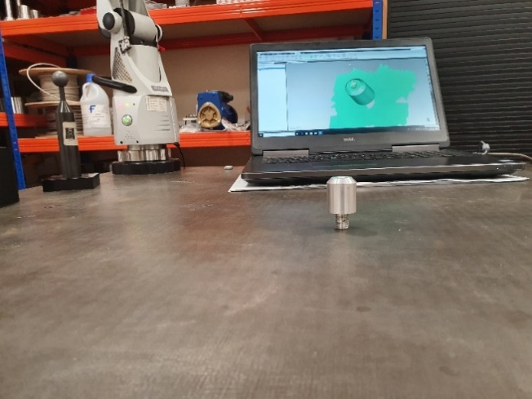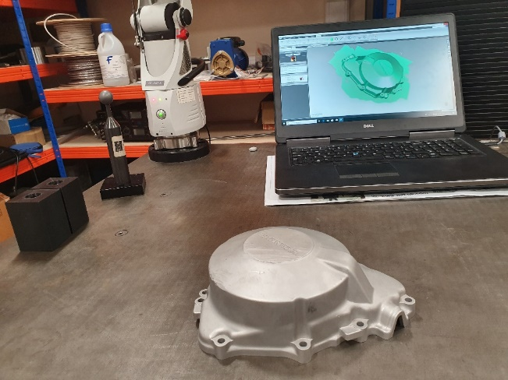Experiment was carried out in a controlled environment with a steady ambient temperature and the AACMM was mounted on a stable platform to counteract any vibration that might influence the integrity of the measured data. Extra care was taken to make sure the part is clean from dirt and positioned at a fixed position. The AACMM is a 7-axis Absolute Arm. Attached to the Articulate Arm is an RS5 laser scanner (specifications are stated in table below) and scanning was performed at a steady pace within good capturing distance monitored by the RDS system with respect to ISO 10360-2. The Arm accuracy is measured according to a variable L which indicates the length of the Arm at which the measurement was performed. A higher value of L indicates that the Arm is measuring at a larger measurement distance and the accuracy increases when the value of L decreases. At the maximum length of the Arm, the volumetric accuracy is 0.0043 mm, roundness uncertainty is ± 0.025 µm and uncertainty of measurement at ± 0.00025 mm at a temperature of 20° C ± 1° C. For best practice, the joints should be positioned near 90° as the encoders are most accurate having the largest angle to distance moved ratio. Positioning the elbow of the Arm at 90° to the base vertical axis produces a parallel projection from the base to the surface being measured and a downwards projection from the elbow produces the preferred positioning of the artefact. This is shown in the figure () below as this gives the maximum range of movement of the Arm’s elbow relative to the artefact. Points are automatically registered on the capturing software as the laser line runs over the surface of the part. A major challenge to how the scanner captures points is the reflectivity of the surface and surface material. The laser scanner generates 725 000 points/s at a maximum point spacing of 0.011 mm. When the laser light runs over the surface of the part, certain factors influences how surface points are generated, this includes the laser scanner in the case of overlaying points where the averaging and blending process happens, the surface texture and colour, the milling pattern and surface finishing. These factors determines the line spacing between points and point generating patterns depending on the geometry of the part at a particular region, i.e. at regions having curves and freeform more points are generated as compared to flat surface. Points generated from a machined part will produce a different pattern from parts moulded/casted and 3D printed. In 3D representation of a part, a major challenge has always been file transfer formats which aids in communication between software.

|  |  |
| --- | --- |
|  | RS5 |
| Accuracy | 0.028 mm (2σ) |
| Point Acquisition Rate | 752 000 points/s |
| Points per Line | Max. 7520 |
| Line Rate | Max. 100 Hz |
| Line Width (mid) | 115 mm |
| Standoff | 165 ± 50 mm |
| Minimum Point Spacing | 0.011 mm |
| System Scanning Certification | Yes |
| Laser Class | 2M |
| Operating Temperature | 5-40°C |
| Weight | 0.4 kg |

1. CONCLUSION

REFERENCE

[1] X. J. Jiang and D. J. Whitehouse, "Technological shifts in surface metrology," *CIRP Annals,* vol. 61, no. 2, pp. 815-836, 2012/01/01/ 2012.

[2] W. Kaibo and T. Fugee, "Using Profile Monitoring Techniques for a Data‐rich Environment with Huge Sample Size," *Quality and Reliability Engineering International,* vol. 21, no. 7, pp. 677-688, 2005.

[3] P. L. Seng and H. Habibollah, "Surface Reconstruction Techniques - a review," *Artificial Intelligence Review,* vol. 42, no. 59-78, pp. 59–78, June, 2014 2014.

[4] Y.-C. Tsai, C.-Y. Huang, K.-Y. Lin, J.-Y. Lai, and W.-D. Ueng, "Development of automatic surface reconstruction technique in reverse engineering," *The International Journal of Advanced Manufacturing Technology,* vol. 42, no. 1-2, pp. 152-167, 2009.

[5] X.-F. Han, J. S. Jin, M.-J. Wang, W. Jiang, L. Gao, and L. Xiao, "A review of algorithms for filtering the 3D point cloud," *Signal Processing: Image Communication,* vol. 57, pp. 103-112, 2017/09/01/ 2017.

[6] S. Orts-Escolano, V. Morell, J. García-Rodríguez, and M. Cazorla, "Point cloud data filtering and downsampling using growing neural gas," in *The 2013 International Joint Conference on Neural Networks (IJCNN)*, 2013, pp. 1-8.

[7] M. Berger *et al.*, "State of the Art in Surface Reconstruction from Point Clouds," in *Eurographics 2014 - State of the Art Reports*, Strasbourg, France, 2014, vol. 1, no. 1, pp. 161-185.

[8] A. Youssef, "Analysis and comparison of various image downsampling and upsampling methods," in *Data Compression Conference, 1998. DCC '98. Proceedings*, 1998, p. 583.

[9] C. Tomasi and R. Manduchi, "Bilateral filtering for gray and color images," in *Sixth International Conference on Computer Vision (IEEE Cat. No.98CH36271)*, 1998, pp. 839-846.

[10] ISO14997, "Optics and photonics: Test methods for surface imperfections of optical elements," 2017.

[11] ISO10110-7, "Optics and photonics. Preparation of drawings for optical elements and systems. Surface imperfections," 2017.

[12] B. Suvdaa, J. Ahn, and J. Ko, "Steel surface defects detection and classification using SIFT and voting strategy," *International Journal of Software Engineering and its Applications,* Article vol. 6, no. 2, pp. 161-166, 2012.

[13] B. M. Colosimo, Q. Semeraro, and M. Pacella, "Statistical Process Control for Geometric Specifications: On the Monitoring of Roundness Profiles," *Journal of Quality Technology,* vol. 40, no. 1, pp. 1-18, 2008/01/01 2008.

[14] M. M. Gardner *et al.*, "Equipment fault detection using spatial signatures," *IEEE Transactions on Components, Packaging, and Manufacturing Technology: Part C,* vol. 20, no. 4, pp. 295-304, 1997.

[15] J. D. Williams, W. H. Woodall, and J. B. Birch, "Statistical monitoring of nonlinear product and process quality profiles," *Quality and Reliability Engineering International,* vol. 23, no. 8, pp. 925-941, 2007.

[16] E. Chicken, J. J. Pignatiello, and J. R. Simpson, "Statistical Process Monitoring of Nonlinear Profiles Using Wavelets," *Journal of Quality Technology,* vol. 41, no. 2, pp. 198-212, 2009/04/01 2009.

[17] L. Kai and Q. Kemao, "Dynyamic 3D profiling with fringe projection using least squares method and windowed Fourier filtering," *Optics and Lasers in Engineering,* vol. 51, no. 1, pp. 1-7, 2013/01/01/ 2013.